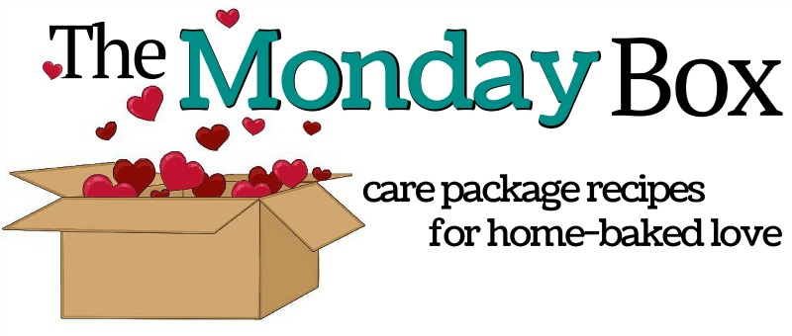

Getting to know you military care package :
“Let’s Play 20 Questions”

- Do you have a favorite cookie or baked treat?
- Which do you like better; vanilla or chocolate? (Yin Yang Cookies)
- How about peanut butter? Cinnamon? Lemon? Mint?
- What is your favorite color? ( Rainbow Cake Mix Cookies )
- When is your birthday?
- Do you like sports? Baseball? Soccer? Football? Basketball? Hockey? Other?
- What teams are your favorites? (Sports Illustrated magazine)
- Do you like puzzle books? Crossword? Soduku? Wordfind? Other? (puzzle book)
- Do you like to play cards or board games? Chess/checkers? Other? (cards)
- Do you have access to a microwave? ( microwave popcorn )
- Do you have access to a freezer? (freezer pops )
- What is your favorite snack food? Pretzels? Chips? Popcorn? (pretzels)
- Do you like spicy foods and sauces? ( canned jalepeño cheese dip )
- Do you drink tea or coffee? ( instant coffee and tea bags )
- Do you need toiletries? Shampoo? Razors? Toothpaste? Deoderant? Other? (toothpaste and toothbrush )
- Do you need supplies for sending letters or greeting cards? (note cards)
- What is your favorite candy? ( box of hard candy)
- What are your hobbies and interests?
- Is there anything else you would like me to know that I haven’t asked?
- Is there anything you need that I might be able to help with?

